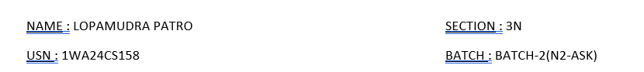

**DBMS LAB WEEK-0 STUDENT DB**

**Q. Open mysql workbench click on the connection ‘root’ and enter the password ‘bmsce’ and you will be logged in to workbench and start typing the following and execute the queries one by one as given below**

1. How to switch to or access database : use mysql;
2. To create a new user : create user name IDENTIFIED BY “USN”;
3. To grant permissions to a User to access database :

GRANT ALL PRIVILEGES ON *.* TO “name”;

FLUSH PRIVILEGES;

4) To view the existing databases type following command and execute:

show databases;

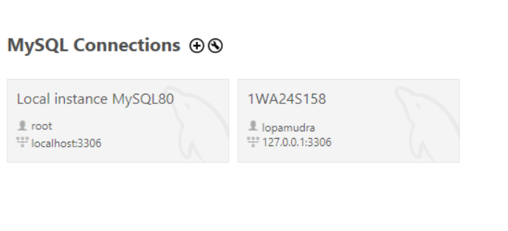

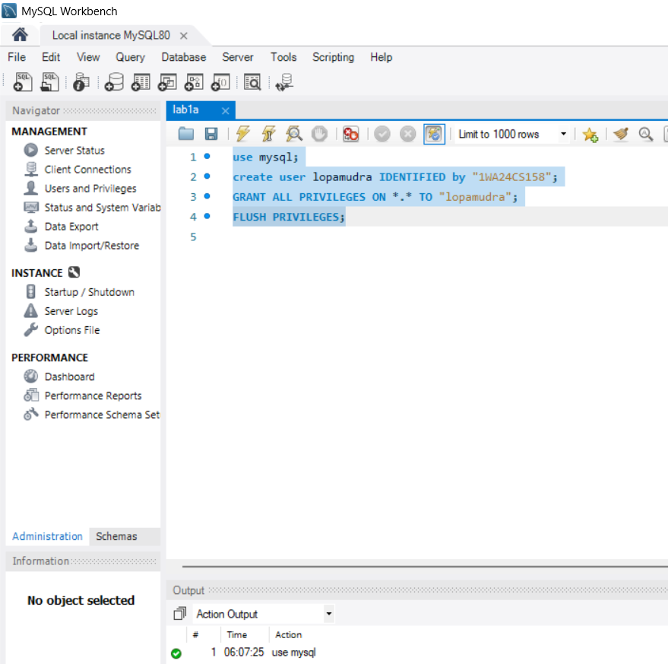

**Q. Illustrate an example to create a table student, student table will**

**contain the following attributes,**

**stdid, stdname, dob, doj, fee, gender etc.**

***Write the following queries:***

● Describe the structure of the table.

● Insert a few records into the student table.

● Add a column to the student table (that is phone_no).

● Modify the column name of phone_no to student_no.

● Rename the table name to student_info

● To drop a column from the table

● Display the content of the table

● Delete any records from the table.

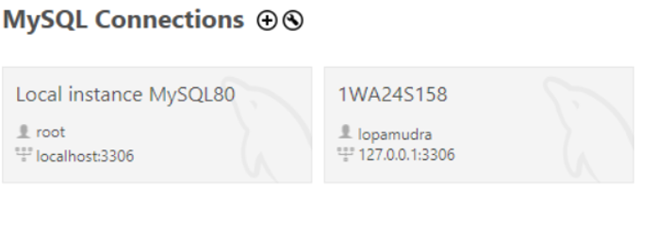

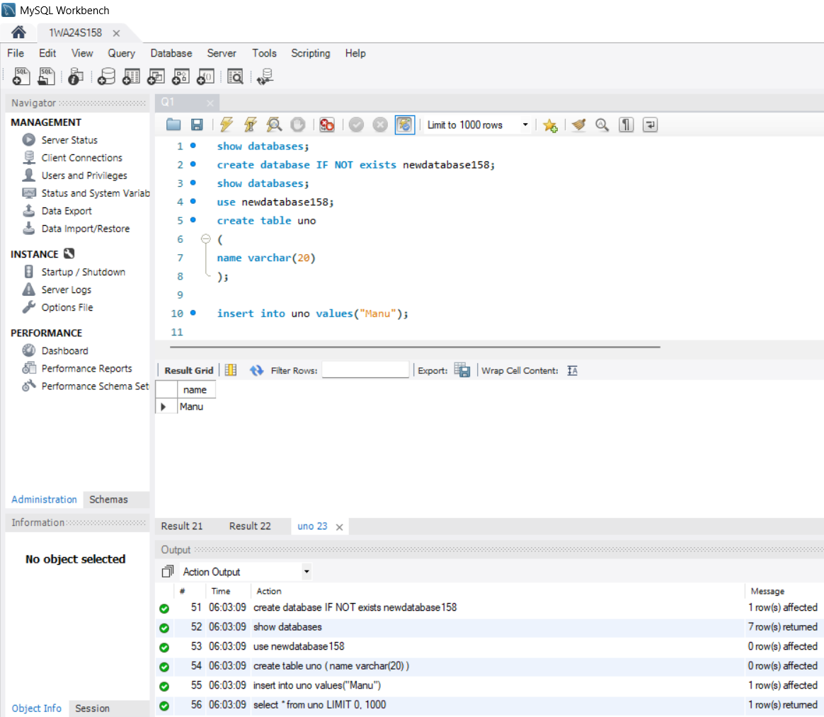

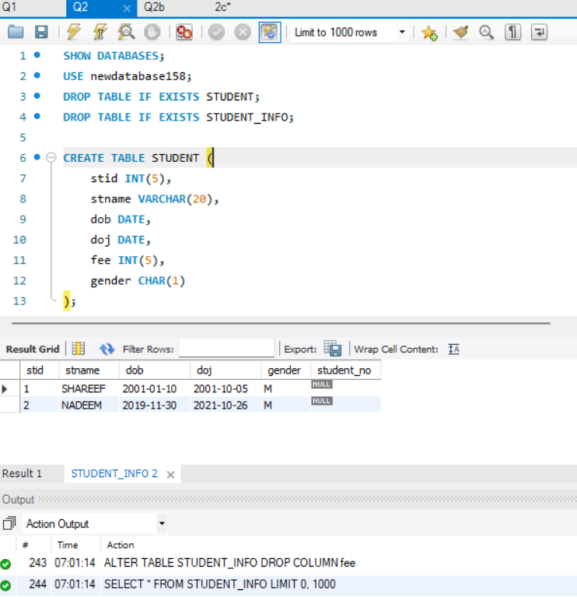

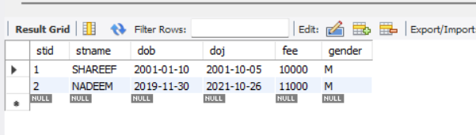

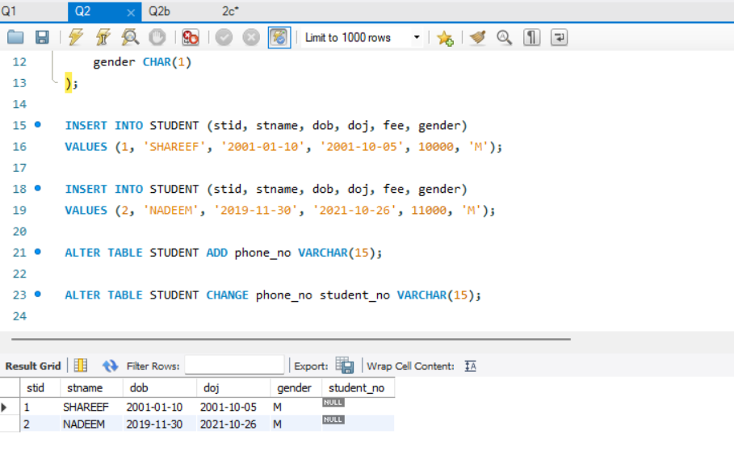

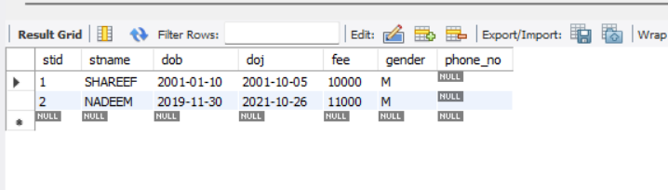

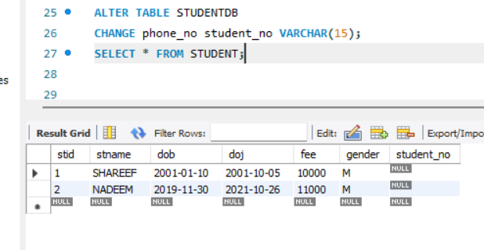

**After we drop a column (fee):**

